Lefins solutions

for: kabondo kasipul women sacco
Project Scope
  - september 31, 2024

Overview

Project Background and Description
KABONDO-KASIPUL WOMEN SACCO is a dully registered SACCO in the republic of Kenya, with its headquarters based at Kadong’o, within Homabay County.
The SACCO is still at its infancy stage and growing very rapidly. As a result, there is an urgent need to automate most of its manual processes in order to: -
- Fasten the operational processes for all the entities concerned within its ecosystems.
- Increase transparency at all levels.
- Increase, and by extension, instill trust among entities involved within its ecosystems.
- Lower the turnaround time for its operations.
- Leverage existing technologies to promote growth among its members.
- Lower operational costs, with the hope of escalating the benefits to its members.

Project Scope
In order to achieve the above named, the project will implement 3-tier, responsive web-based application system that will be accessible over the internet through: -
- Smart phones - member access only
- SMS and short-code - member access only
- Small devices (ipad and ipad-like devices) - both members and management.
- Laptops, desktops and large system – both members and management.
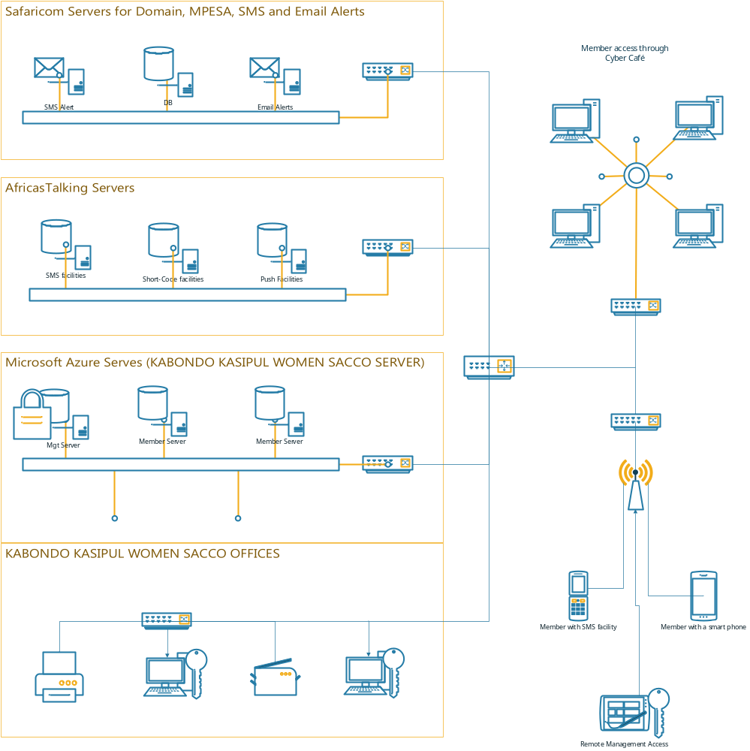
The functionalities that will be implemented at a high level are: -

Membership Module
Membership module will include: -
- New members’ registration process and records keeping.
- Maintenance of existing membership records.
- Management of membership status in full compliance with the SACCO constitution.
- Management of membership deregistration process.
- Members access management to their individual accounts.
- Management of membership alerts modes and levels.
# | MEMBER OPERATION | REQ. | PROVIDED | ACCESS
1 | Register member | FORM | YES | Management
2 | Capture member/spouse/dependents photo | NA | NA | Management
3 | Save scanned/picture of application form | NA | NA | Management
4 | Approve new member registration | Process | NO | Management
5 | Create member online access | NA | NA | Management
6 | Reset member access credential | NA | NA | Management
7 | Disable member online access | NA | NA | Management
8

# | MANAGEMENT OPERATION | REQ. | PROVIDED | ACCESS
1 | Provision supper user | NA | NA | System
2 | Provision other users [teller, loans approver, members registration] | List | NO | Super-user
3

# | ROLE | ACCESS | COMMENTS
1 | SUPER-USER | ALL | Can do everything
2 | LOANS-MANEGER | LOAN APPROVAL  LOAN REFINANCING APPROVAL
3 | TELLER | MEMBER REGISTRATION  SAVINGS COLLECTION  SHARES COLLECTION  CASH-TO-BANK DEPOSIT
4

Loans Module
The SACCO offers loans to its members. The loans module will include: -
- Loan application process
- Loan approval/rejection process
- Loans business logic that ensures compliance with the SACCO rules
- Loans recovery process
# | OPERATION | PROVIDED | COMMENTS
1 | Loan/refinance application | YES
2 | Loan approval workflow | NO
3 | Loan rejection workflow | NO
4 | Loans schedule | NO
5 | Loan recovery | YES | Is it linked to savings accounts?

Savings and Shares Module
The purpose of the SACCO is to encourage savings by members. Savings module would be concerned with deposits into members’ accounts. The periodic share deductions will be made automatically from member savings accounts.
# | OPERATION | COMMENTS
1 | Share deposit
2 | Savings deposit
3 | Savings withdrawal
4 | Book-keeping charges? | Are there book keeping charges?

Alerts module
There will be two modes of alerts: -
- Emails
- SMS.
There will also be the ability by members to enquire about their savings, shares, loans status via a short-code that will be provided.
The system triggered alerts will be customizable per member to enable members decide what sorts of alerts they would rather receive and within what cycle.
# | SMS ALERT TRIGGER | COMMENTS
1 | Savings deposit
2 | Shares deposit
3 | Loan repayment
4 | Loan application
5 | Loan approval
6 | Accounts creation
7 | Password reset
8

# | EMAIL ALERTS | TRIGGER | COMMENTS
1 | Accounts status | MONTHLY
2 | Accounts creation | AS
3 | Password reset | AS
4 | Loan application | AS
5 | Loan approval | AS
6 | Loan status | MONTHLY
7

Reports
There will be several reports that will accompany the software. The rest of the reports will be as will be requested.
# | REPORTS
1 | Members list
2 | Reconciliation form
3 | Member application form
4 | Loan application form
5

High-Level Requirements
The system is web based application. As such, any device with internet access and the latest browser, will be able to access it. In addition, there will be SMS capabilities that can be utilized by any device with SMS capabilities.

The new system must include the following:
- Ability to allow both internal and external users to access the application without downloading any software
- Ability to interface with the existing data warehouse application
- Ability to incorporate automated routing and notifications based on business rules

Deliverables
- Back-end software that is hosted in the cloud.
- UI Prototype for both members and management.
- Management web based application, accessible through specific authorized computers.
- Members responsive web based application accessible.
- User documentation manual.
- Technical documentation

Affected Parties
- Management
- Members

Affected Business Processes or Systems
- Member registration
- Loan application
- Loan approval process
- Deposits
- Loan repayments
- Accounts status enquiries.

Specific Exclusions from Scope
In this phase (phase 1), the following will be excluded and will come in the subsequent phases: -
- Direct MPESA connection through the API, that will enable real-time deposit reflection into the members’ accounts without human interaction.
- Direct Bank connection through the SACCO bank API that enable real-time deposit reflections into the member’s accounts.
- Integration with existing systems (if any).

Implementation Plan
The project will kick off with the implementation of stubs necessary to enable development of the prototype.
After the stubs, the UI prototype will be developed. Once the prototype has been developed, the SACCO officials will go through it and approve of it. This stage is to ensure that all required functionalities have been factored and that the user experience (UX) is excellent.
After the UI prototype has been done, the stubs will be replaced with the business logic, starting with members’ module, followed by savings and shares module, then loans module last.
Email and SMS alerts will be integrated as part of modules development.
Signing off, commissioning and training will follow thereafter.

High-Level Timeline/Schedule
# | Date | Description | Dep. | Comments
1 | 03/1/2017 – 13/1/2017 | UI Prototype/Wireframe
2 | 14/1/2017 – 20/1/2017 | Membership module implementation | #1
3 | 21/1/2017 – 27/1/2017 | Savings + Shares module implementation | #2
4 | 28/1/2017 – 03/2/2017 | Loans module | #3
5 | 06/2/2017 – 10/2/2017 | Official commissioning + training management | #4
6 | 13/2/2017 – 14-2/2017 | Training of members | #4

Approval and Authority to Proceed
We approve the project as described above, and authorize the team to proceed.
Name | Title | Signature | Date
Felix Otieno Okoth | Mr. |  | 31/12/2016
Joseph Hezekiah

Approved By |  |  | Date |  | Approved By |  |  | Date

